~~Home/Introduction~~

~~Brief introduction of yourself<br>~~

~~Professional photo<br>~~

~~Contact information (email, LinkedIn, GitHub, etc.)<br>~~

~~<br></strike>~~

            About Me<br>

            Detailed background information<br>

            Education<br>

            Relevant skills and technologies<br>

            Personal interests and hobbies<br>

            <br>

            Projects<br>

            Showcase your key projects with descriptions<br>

            Include technologies used, your role, and outcomes<br>

            Links to live demos or GitHub repositories<br>

            <br>

~~Experience<br>~~

~~Professional work experience<br>~~

~~Internships, teaching assistant roles, and other relevant positions<br>~~

~~Descriptions of your responsibilities and achievements<br>~~

            <br>

            Skills<br>

            List of programming languages, frameworks, and tools<br>

            Proficiency levels (e.g., beginner, intermediate, advanced)<br>

            <br>

            Education<br>

            Academic background with degrees, institutions, and graduation dates<br>

~~Notable courses and relevant projects<br>~~

            <br>

            Certifications<br>

            Any relevant certifications (e.g., AWS certification, merit scholarships)<br>

            <br>

            Blog/Articles<br>

            Optional section for sharing articles, tutorials, or thoughts on topics related to your field<br>

~~Contact<br>~~

~~Contact form for visitors to reach out to you<br>~~

~~Additional contact information<br>~~

~~Resume<br>~~

~~Downloadable PDF version of your resume<br>~~

            Testimonials/Recommendations<br>

            Optional section with testimonials from colleagues, professors, or clients<br>

            <br>

            Portfolio Gallery<br>

            Visual showcase of your projects, designs, or other work<br>

            <br>

            Achievements and Awards<br>

            List of any awards, recognitions, or scholarships you have received<br>

        </p>

    </div>

**More about me section**

Accenture- Advanced App Engineering Associate

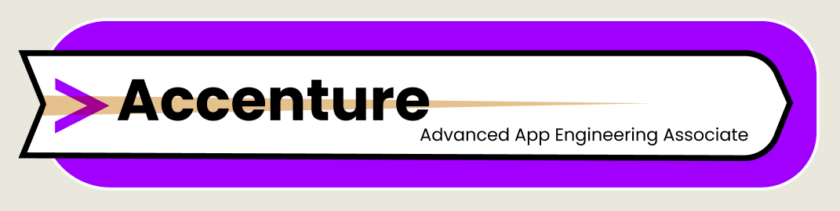

Cognizant- Programmer Analyst

TCS- Assistant System Engineer

Capgemini- Analyst

Wipro- Project Engineer

VIRTUSA- Associate Software Engineer

**Color palette**

**Portfolio inspirations**

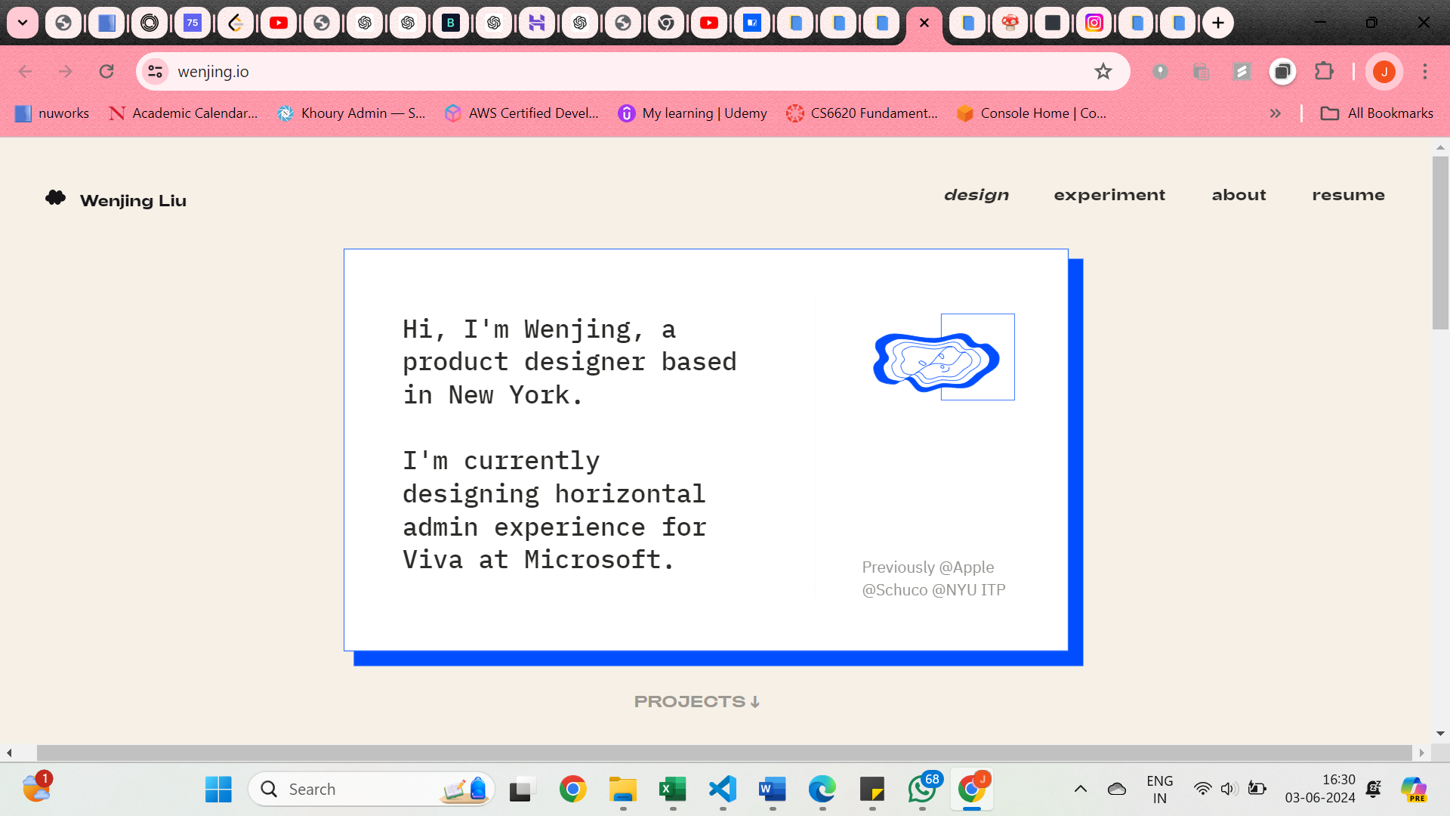

**PROJECTS**

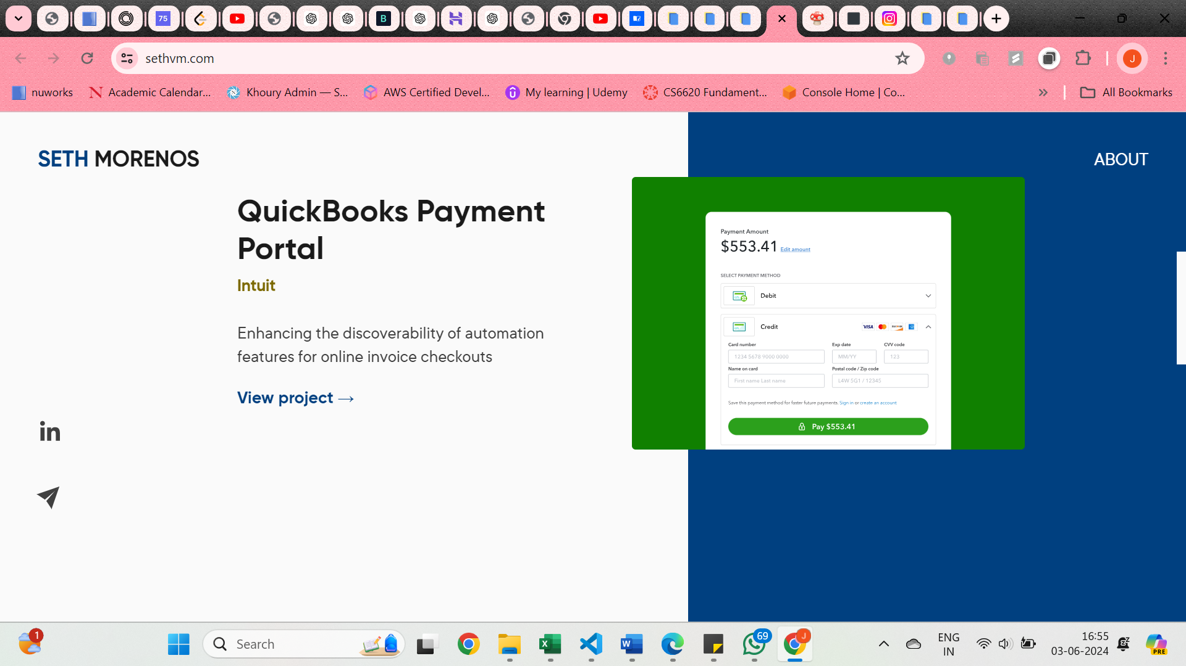

**CERTIFICATIONS**



**SOCIAL MEDIA PROFILES**

Certainly! Here are the main sections you should consider including in your portfolio:

1. **Home/Introduction**

- Brief introduction of yourself

- Professional photo

- Contact information (email, LinkedIn, GitHub, etc.)

You must be wondering she claims that she has experience working with web applications working as front-end and back-end. What sets her apart??

Well, that is true, but what sets me apart is my ability to combine my technical skills with a strong sense of design(along with meticulous nature added to the cart).

Well, that is true, but what sets me apart is my knack for blending technical expertise with a strong sense of **design**. Whether I’m crafting user-friendly interfaces or optimizing backend processes, I ensure that **form** always meets **function**. My colleagues and professors often describe me as a proactive **problem-solver** who brings a creative perspective and **meticulous** nature to tech challenges.

2. **About Me**

- Detailed background information

- Education

- Relevant skills and technologies

- Personal interests and hobbies

3. **Projects**

- Showcase your key projects with descriptions

- Include technologies used, your role, and outcomes

- Links to live demos or GitHub repositories

4. **Experience**

- Professional work experience

- Internships, teaching assistant roles, and other relevant positions

- Descriptions of your responsibilities and achievements

5. **Skills**

- List of programming languages, frameworks, and tools

- Proficiency levels (e.g., beginner, intermediate, advanced)

6. **Education**

- Academic background with degrees, institutions, and graduation dates

- Notable courses and relevant projects

7. **Certifications**

- Any relevant certifications (e.g., AWS certification, merit scholarships)

8. **Blog/Articles**

- Optional section for sharing articles, tutorials, or thoughts on topics related to your field

9. **Contact**

- Contact form for visitors to reach out to you

- Additional contact information

10. **Resume**

- Downloadable PDF version of your resume

11. **Testimonials/Recommendations**

- Optional section with testimonials from colleagues, professors, or clients

12. **Portfolio Gallery**

- Visual showcase of your projects, designs, or other work

13. **Achievements and Awards**

- List of any awards, recognitions, or scholarships you have received

To get started, you can use a platform like WordPress, GitHub Pages, or a custom-built website using HTML, CSS, and JavaScript frameworks. Deploying your portfolio can be done through various hosting services such as Netlify, Vercel, or AWS.

Would you like detailed steps on how to build and deploy this portfolio?